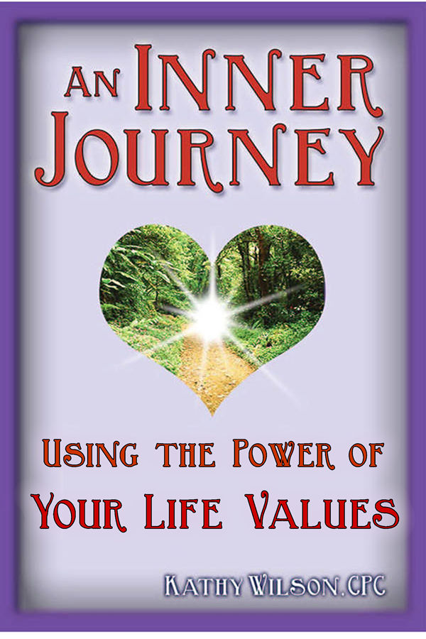
An Inner Journey: Using the Power of Your Life Values
Copyright © Kathy Wilson
ALL RIGHTS RESERVED. No part of this book may be reproduced or transmitted in any form or by any means, electronic or mechanical, including photocopying, recording, or by any information storage and retrieval systems without permission of the author except where permitted by law.
Faith
When you walk to the edge of all the light you have
and take that first step into the darkness of the unknown
you must believe one of two things will happen:
there will be something solid for you to stand upon
or, you will be taught how to fly.
Patrick Overton
Rebuilding the Front Porch of America
Copyright 1997 by Patrick Overton
Reprinted by permission of Patrick Overton

Your Life Values
Your life is a journey and, like any journey, things go more smoothly when you've made the proper preparations.
When you prepare for any journey, it’s important to pack the right things to bring with you. Your travels will be smoother, easier, and you'll have a more enjoyable trip if you have the appropriate and necessary items with you. You wouldn’t want to take polar fleece clothing with you to Costa Rica, for instance.
Taking the right kinds of clothes, your personal toiletries, and any miscellaneous necessities such as your passport or a camera, can make the difference between a frustrating experience and a delightful adventure.
Likewise, having the proper preparations completed before you set off on the journey of living your life purpose will insure that you’ll have an easier time of it - and you’ll enjoy the trip more.
As with any travel, you’ll be taking a bag of necessities with you as you journey to living your life purpose. Included in this bag are some very important and fundamental items - the most important of which are your life values.
It will be most helpful for you to have a notebook handy as you go through this ebook. There are many exercises that involve writing, all of which are designed to broaden your learning and deepen your experience.
What are Life Values?
Your life values define you, the true inner you, your core essence. They form the very foundation of your life and are reflected in everything you think, feel, and do. They’re the basis and the meaning of your life.
Your life values are some of the most important clues that you set up for yourself to help you remember your life purpose. They serve as guideposts, pointing the way for you and keeping you on your true path.
They serve to guide you throughout your entire life. All of your choices, judgments, and decisions are filtered through them, whether you’re aware of this happening or not.
Life values are intangible, which can make them a little challenging to define since you can’t see them, touch them, or smell them. They aren’t something you can possess or own. For example, money is not a core life value, although there are some things associated with it that are life values, such as fun, security, and freedom.
Life values are not what you do, although they are reflected in how you do it. For example, someone who has a life value of beauty might build a house that is aesthetically pleasing to them. Someone else who has a life value of security would probably care less about their house being beautiful, but they would care that it’s strong, durable, and has big locks on all the doors and windows. As both build their house, how they do it reflects their life values.
Life values aren’t morals or principles. If you feel righteous or ethical about what you’re doing, it’s not a life value. It’s a moral. Morals are laws, written or unwritten, stated or implied, putting rules to principles and ethics. If you’re following rules, you’re following principles and not your core life values. There are no laws or rules in life values. They just are.
If there’s a certain value you’d like to have, such as kindness or orderliness, then it’s not your life value. If you want more of a value in your life, or if you have to put effort into achieving it, then neither is it your life value. It’s either somebody else’s value or it’s a “should”, which also belongs to someone else. Know that life values come from the core of your being and they do so effortlessly.
Life values aren’t something you acquire along the way because of the experiences you’ve had. Those are beliefs. As you go through life and gather experiences, you make judgments about what you’ve experienced. "This is good", or "that’s bad"; "it’s right" or "it’s wrong".
Although beliefs are typically acquired from the judgments you’ve made about the experiences you’ve had, they can also be inherited. Not only can you get them from your parents, you can also get them from your teachers, older siblings, friends, the media, and many other sources that might influence you.
If you have to have it in order to be happy, then it’s a need, either yours or someone else’s. You don’t need a life value. You already have a complete set of them.
The bottom line difference between life values and morals, principles, beliefs, needs, is that life values reside inside of you. The rest are acquired from outside influences.
Life values are not difficult. They're as much a part of you as the fingers on your hands. You don’t have to work for them or follow rules to get them.
You can’t wish them away or trade them in on others that you think you might like better. Most people wouldn’t trade their life values for any other values anyway. They love the life values they have and are darn proud of them.
Most people have about ten primary life values. While these core life values don’t change or go away during their lifetime, they may exchange places in priority for a time in accordance with life experiences.
There are usually from three to five core life values that remain at the top of the list and stay there permanently.
Your Life Values and Your Life Purpose
Your life values have been with you since before you were birthed and will continue to be with you until the end of your days this lifetime. You chose them as a part of your Soul Contract for this lifetime in order to assist you in living your life purpose.
Your life values are always in direct alignment with your life purpose.
Before you were birthed onto this planet, you chose the life values which would be most important to you and would predominate in your life. These are major clues that you set up for yourself so you could remember your life purpose - the guideposts that point you to your true life path. Your life purpose and your life values mesh like well-oiled gears.
As an example, a person who chose to be of service to others by doing healing work related to teaching may have core life values of knowledge, wisdom, humor, learning, and creativity. They would most likely not have life values of romance, recognition, fame, wealth, and power.
How do Life Values work?
Everything you do or think is filtered through your life values. Everything.
Here are some examples:
The people you're attracted to have life values compatible to yours. This serves as reinforcement for you and encourages you to honor your life values. More importantly, these people are the ones who will be your strongest supporters as you’re living your life purpose.
The people you dislike or who repulse you have life values incompatible with yours. They mirror for you the downside of what happens when you don’t honor your life values. Please note: these people will not support you in living your life purpose.
Activities you enjoy are in direct alignment with your life values. Those that you dislike - the kind that drain your energy and leave you feeling disgruntled - are directly opposed to your life values. Both of these types of activities - those you like and those you dislike - are major clues about the nature of your life purpose.
Environments that aren’t pleasing to you are not in alignment with your life values. A person whose life values include peace, simplicity, and privacy would be much happier living in the country than in a busy, noisy, heavily populated city. The environment you’re most comfortable in offers another clue to your life purpose.
All that is in alignment with your core life values, such as another person’s behavior, a situation or event, an environment, or an object, will be pleasing to you. You’ll find yourself attracted to it.
If anything is not in alignment with your life values, you’ll find yourself uncomfortable with it in some respect. When you’re around it, you’ll have a sensation of being repulsed or resistant, which will manifest in some form of negative emotion such as fear, distaste, impatience, anger, or resentment.
Pay attention to your feelings. Those sensations are your Soul at work, gently guiding you toward your life purpose.
Your Automatic Filtering System at Work
Remember that everything you do, say, and think is filtered through your life values, whether you’re aware of it or not.
Every choice you make is either in alignment with your life values or not. Each choice you make that's in alignment with your life values will be beneficial to you somehow and your life will be made better because of it. If the choice you make is contrary to your life values, you’ll experience difficulties with the results of your choice.
For example, assume that a person has truth as one of their most important life values. Perhaps their definition of it is the same that our court system uses to swear in someone who’s going on the stand: ”the truth, the whole truth, and nothing but the truth”. That definition pretty much covers it all. When that person then omits a part of that definition in their communications with people, they’ll suffer the consequences of their choice.
If, for instance, they neglect to tell a potential client that all communication including emails and phone calls, is considered billable hours, they’ll face an uncomfortable quandary every time they have a conversation with the client.
> Do they bill the client for their time and expertise even though they didn’t make it clear that this would happen?
> Do they eat the time and lose the revenue?
> If they choose to not bill the client, are they going to feel resentful towards them afterwards?
> And how much time and energy do they want to waste on tossing this issue back and forth before they finally make a decision they can live with?
As you can see, being truthful with the client to the full definition of their value and telling them clearly and completely that they will be billed for all time spent in communication with the client, their life is much easier and smoother.
When you consciously choose to honor your life values, you too will have a life that is easier, more effortless, and flows more smoothly. The choices you face will become easier to make as you get more clear about your life values. And the choices you make will lead to a higher quality life.
Most importantly, you’ll be living your life congruent with your life purpose - the meaningful work you desired to do this lifetime in order to be of service to others.
Getting Control of Your Life
If you choose not to honor your life values, you’ll find your life is more difficult. You may feel like you have little or no control over your life, which is exactly what happens.
When you aren’t honoring your life values, you’re living your life by default. You’re allowing other people to make decisions about your life and, by doing so, you put yourself in the position of being a victim.
Each time you allow outside influences such as other people, situations, conditions, and even your environment, to determine your life, you’re giving your personal power away. Without your personal power, you lose your direction and focus, which causes you to move away from rather than toward your life purpose.
When you live your life based on your life values, you are the one making the choices about your life.
Who else knows what’s best for you?
What’s that you say? Your mother? I don’t want to give mothers a bad rap, but despite that knock-kneed cliché, your mother doesn’t always know what’s best for you. This is especially true after you’ve reached adulthood.
Neither do your teachers, bosses, co-workers, friends, lovers, or other family members know what’s in your best interest.
You are the only one who knows the choices that are best for you.
If you’re having difficulty making an important decision, it’s because you aren’t clear about your life values. Once you've identified your most important life values, it becomes easier and simpler to make choices. When you make a choice that isn’t in alignment with them, the results will make your life more difficult.
Yes. It’s that simple.
Your life values are the brightly-lit neon signs pointing you toward your life purpose. If you’re ready to begin living your life purpose, then you’re ready to take the first step - identifying your life values.
Identifying Your Life Values
Some people know without a trace of doubt what their main life values are. Just ask someone what’s most important to them and in many instances the answer is their number one life value.
When I asked my wonderfully wacky “90something” neighbor that question, she didn’t hesitate for a New York second before answering “equitability.” It’s most important to her that things are fair, and that’s how she lives every aspect of her life.
For the majority of us humans, however, recognizing our life values can be somewhat of a challenge. I’d hazard a guess that about 85% of the general populace has never given a moment’s thought to their life values, much less clearly understands what they are. After having read to this point, you are in the elite 15% who at least know what life values are.
To help you in determining your life values, here's a review of the guidelines defining what they are not:
Morals give you a feeling of being righteous or ethical.
Principles follow rules.
“Shoulds” don’t come easily and usually feel forced.
Needs are what you think is necessary for you to have in order to be happy.
Beliefs are acquired from life experiences.
Emotions are what you feel.
Tangible. You cannot see, taste, feel, or smell life values. They're invisible qualities that reside within.
Below is a sample list of some values. Select ten values that are most important to you and write them in your notebook. You can combine values, such as honesty/truth or risk/adventure if the combination seems to define them more completely for you. You can also add any values of yours that don’t appear in this list.
Before you get into this exercise, it's important to note that for the purpose of this exercise, love is defined as an emotion, not a value. Think of the choices this way: almost every value in this list can be one of the many different faces of love.
Now, go ahead and select your top ten core life values from the following list and write them in your notebook:
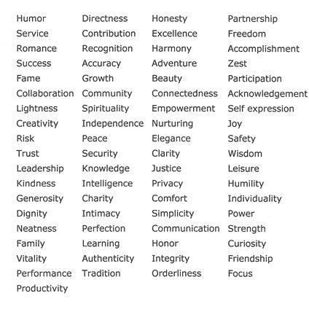
Having trouble identifying your top ten life values? Here are some helpful hints to make the process easier.
Start by deleting any that you absolutely know aren’t your life values, those that you know aren’t very important to you. That should narrow down the choices a bit. Then go through the list again and eliminate those that are questionable - the “maybes”. After doing that, you should be getting down to the nitty-gritty in your list.
Next, cross out or delete the ones that you think aren’t yours. Now cross out any that just don’t seem to be your values. Go through whatever is left and pick your ten most important values.
Enlist the help of some of your friends. Make copies of the list of values and give them to people who know you, and who you can trust to be honest but not brutal or cruel. Have them choose ten values that they see you exhibiting most often.
Think of ten people that you admire. What are the qualities about them that you admire? These qualities are the values that you’re in alignment with because they’re the same or similar to your life values.
Think about some of the most important people that you’ve chosen to have in your life, such as your best friends. (These are people you choose to have in your life, not people you have little or no choice about, like family or bosses.) What are some of their qualities that you admire? These qualities are the life values you use as a filter when you select whom you want in your life.
What’s Important to You?
Still unsure of what your core life values are? Answer the following questions. (There may be more than one value in each answer. That’s ok. At the end you’ll sort through them.) As you discern your answers, write them in your notebook.
1. What’s most important to you about the work you do?
2. What’s most important to you about your home?
3. What’s most important to you about money?
4. What’s most important to you about your life partner?
Now, go through your answers and see what common themes you find, or what words are repeated or seem to stand out. Add them to your list of your life values.
Reflections of Your Life Values
If you’re still not clear about what your life values are, take a look around you. Everything you have in your life reflects choices you made using your life values as the criteria for your decisions. Those things you like and enjoy are in alignment with your life values while the things you dislike, detest, or tolerate are in opposition to your life values.
Imagine that you’re viewing the things you have in your life from the perspective of a stranger.
What would a person’s likes and dislikes have to be in order to create what you have in your life?
What would be important to them? What would they believe?
List in your notebook any descriptive words that come to mind as you visualize the items listed below:
Personal Vehicle
Home
Clothes
Friends
Music
Colors
Using a red pen, highlighter, or color crayon, circle the descriptive words which reflect those things you love. Your life values are reflected in these descriptions.
Circle any words that describe your dislikes in heavy black ink. These words are the opposite of your life values. Simply flip them into their reverse meaning and you’ll find they have elements of your life values in them.
Compare the words you’ve circled with the ten most important life values on your list. You should find similarities and perhaps clearer definitions of some of the life values already in your list. You may have even discovered some new ones.
Allow the work you’ve done so far to settle for a few days and then revisit the list you’ve created of your ten most important life values. You’ll find that when you look at your list again you’ll have a new perspective of it.
You may be amazed at how accurate it is or you may see some values that you wish to tweak, eliminate, add, or replace. The first version may be perfect or there may be a few more versions of your list before you absolutely know that the values within it are, unquestionably, your life values.
Your Very Own Definition of Your Life Values
Webster isn’t the only one who can assign meaning to a word, you know. Everyone has words that have unique and special meaning for them.
For example, “security” can mean very diverse things from one person to the next. One person may define it as having a loving, nurturing family. For another it may mean having inner strength. There are different types of security, too.
Financial security for one person may mean a 9-to-5 job, but for another it may mean having a huge savings account. For yet another it may mean a very large line of credit.
Spiritual security may mean being able to safely pray to the god of one’s choice, or it may mean having complete confidence that the belief one has chosen is the right one.
Physical security for one person may mean safety from physical abuse. For another it may mean having a sturdy, well-built house to live in.
In order to use your life values with confidence and clarity in the everyday world, it’s important to completely understand what they mean to you.
The following exercise will give you the opportunity to do just that.
Write each of your top three core life values in your notebook, leaving space between them for additional writing. Then write your own personal definition of what each one means to you.
Do this in whatever way works for you - as a dictionary-type definition, as a list of words with similar meanings, as a description of how you know when you are experiencing this value, or any other way that makes sense to you.
Keep these three most important life values and their definitions in a place where you’ll be able to see them often during the day so that you’ll come to completely understand what they mean to you.
So far, you have clearly identified your ten most important life values and have clearly defined the top three and so that you clearly understand what they mean to you.
Now what?
Live Your Life Values
With your life values clearly in mind, you can now begin to live them. When you’re living your life values you stay centered and balanced. You aren’t easily thrown off balance by outward influences such as other people, your environment, and events.
When you make choices based on your life values, you’re in a power position and not in victim mode. You avoid becoming a victim to the whims of other people, events in your life, and your environment. You choose what you’ll do, think, and feel in every instance.
The power of choice gives you control in your life.
Here’s an example. Suppose that the phone rings and it’s a client telling you that they no longer require your services. You might choose to think:
> they rejected you, and then choose to feel hurt.
> you must be really bad at what you do, which then contributes to unworthy thoughts and feelings about yourself.
> this is a great opportunity to find out what they liked about your services, what they didn’t like, and how you could improve. You then feel excited about your new growth.
> _________________(fill in the blank space with another response you might choose)
Now, review these choices and consider:
1. What are some of your life values that are being honored in these choices?
2. How are they being honored?
3. Which of your life values aren't being honored by some of these choices?
4. How aren't your life values being honored?
Living Your Life Values Part I
For the purpose of helping you understand more clearly how honoring your life values makes your life better, let’s use a real example from your life.
Think about a situation that you experienced where things weren’t going well and you were feeling upset, angry, or frustrated.
Describe in your notebook what was happening and be as specific and detailed as possible. Who was involved? Where was it happening? What were you feeling?
Now, go back to your list of core life values. Which of them were not being honored? Make note of them.
Replay
Imagine this same situation taking place with one vital difference: now you are honoring your life values. Describe in your notebook how the situation might evolve differently as you replay it, living your life values.
> Which of your life values were you honoring in this replay? Make note of them.
> What are you feeling now about the situation?
Living Your Life Values Part II
Sometimes you have an experience with someone and it goes so smoothly you’re amazed at how easily it flows. "What magical forces were at play?" you might wonder.
No need to wonder. The magic was within you. Whether you were aware of it or not, you were honoring your life values.
Think of a real life situation you experienced that ended as a win-win success, but that could have gone the other way and become a disaster. Think back to your part in the event. Describe it in your notebook.
> What did you say and do?
> What was happening?
> Who else was involved?
> Which of your life values were at play in this situation?
Your Strengths and Qualities
One of the ways in which your life values influence who you are is through your inner strengths and qualities. As an example, a life value of orderliness may manifest as inner qualities of being immaculate with personal attire, having an ability to create organization from chaos, or always being on time.
In this next exercise you’ll identify some of your major inner qualities and strengths, and then connect them to your life values.
You may want to do this exercise first on your own, and then, for additional insights, do it with a trusted friend or loved one.
Take a few moments to consider what qualities best describe you. What qualities are you known for in your circle of friends?
In your notebook, list 10 qualities and next to each quality note the life value(s) that it represents.
Take a few minutes to review how your inner qualities and strengths reflect your life values.
What themes or patterns do you see? Write them in your notebook.
These qualities are guideposts to your life purpose. Muse upon how they are guiding you in your choices toward living your life purpose. Write any new awarenesses in your notebook.
Your Nature Story
Connecting with nature is a grand way to tune in to your deeper self and the wisdom that resides within you. The following exercise may offer some surprises for you.
Take some time to be in nature. Go for a walk in the woods, in a park, or along the beach. Look around and notice all the different elements of nature.
Pick something that calls to you - a rock, a tree, an animal, a leaf. Focus on the object, and as you do so, imagine actually being it.
When you feel that you have the essence of whatever you’ve selected, begin to write in your notebook about what it’s like to actually be this thing.
What new insights were revealed to you in your story? What new awarenesses do you now have about your life values and your life purpose?
Now, go back through your story and circle or highlight words or phrases that represent your life values.
Do/Think/Feel
Life values are the foundation of living your life from the inside out and making your own choices based on what’s best for you. Living your life from the outside in puts you in the position of being a victim to outward influences, such as the whims, desires, and needs of other people.
A little practice will go a long way to make living your life values as automatic as breathing. For the next week, take a few moments at the end of your day to note which of your life values you used to make a choice or a decision. Use this format:
Life Value:
What I did:
What I thought:
What I felt:
You may want to continue tracking your use of your life values even longer than a week in order to record your progress. You might also want to use this record as a future reference to recall how you’ve successfully used your life values.
Consciously filtering your choices through your life values puts you in control, allowing you to easily and fluently create a better quality life for yourself.

More Ebooks from Kathy Wilson
An Inner Journey: Living Your Life Purpose
If you enjoyed this ebook, then you'll really love An Inner Journey: Living Your Life Purpose. It's the complete collection of all Inner Journey ebooks - twelve chapters (including this one) in a sequential format to gently guide you as you integrate your life purpose into your everyday life.
When you feel like there has to be more to life your, that life is not as satisfying as you know it could be, then you're receiving nudges you’re your Soul that there's something very important missing from it. What's missing is your life purpose - the soul-satisfying work of your destiny. An Inner Journey leads you to your destiny.
www.Warrior-Priestess.com/ebook-innerjourney.html

Omnidimensional Oracles: Universal Knowledge and Practical Wisdom for Human Evolution
It's evolutionary! Simple in form yet powerful in use, the 66 symbols in this ebook are an introduction to unlocking the secrets of our world. The information contained within the description of each symbol can take you from the very beginning stages of understanding Universal concepts to the greatest utilization of them in our world.
www.warrior-priestess.com/ebook-Omni.html

Visit the website for a complete list of print books and ebooks:
http://www.warrior-priestess.com/healing-products.html

